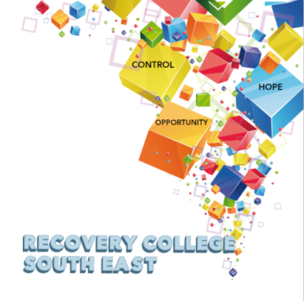
PO Box 16
Abbey Business Centre
Abbey Street
Kilkenny
recoverycollegesoutheast@gmail.com
086 8185760 Clare Fitzpatrick
Coordinator
086 1746330 Amanda Quigley
Peer Educator

Semester 1 Workshops- Recovery College South East

Who Are These Workshops Open to?

The College will provide a range of educational workshops that focus on wellness, recovery and self-management skills in mental health and addiction. All our workshops are free, however there is an enrolment fee of €5 per semester per student. Our workshops are also open to everyone. The ethos of the Recovery College South East is to empower people to educate themselves around wellness in mental health and addiction. Workshops are open to people with mental health and/or addiction challenges, their supporters and families, people who work in the sector or those who wish to have a better understanding of their own wellness and that of others.

How to Enrol

- Check which courses and workshops are running this term in our attached timetable.
- Choose your courses and workshops.
- Contact the Recovery College South East for an application form.

Email: maryrecoverycollegesoutheast@gmail.com
Phone: 056 7771094
Mobile: 086 1746330

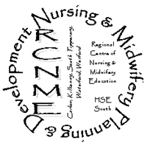
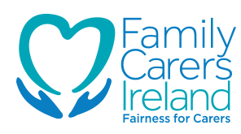
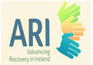
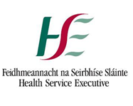
Recovery is moving on, achieving and learning, being the best and the best that I can be with confidence” Mental Health Discussion Group Clonmel 2013

VENUE | WORKSHOP NAME | DATES | TIME
CARLOW
Carlow Institute of Technology,  Kilkenny Road,  Carlow | Let’s Talk Recovery | Nov 21st, 28th,  Dec 5th, 12th | 10am to 1pm
 | Living Without Depression | Nov 23rd, 30th,  Dec 7th, 14th | 10am to 1pm
The Involvement Centre, St. Dympnas Hospital, Athy Road, Carlow | Taking Back Control | Dec 9th | 10am to 4pm
 | Taking Back Control | Dec 16th | 10am to 4pm
KILKENNY
St. Patrick’s Parish Centre,  Loughboy, Kilkenny. | Let’s Talk Recovery | Nov 22nd, 29th,  Dec 6th, 13th | 2pm to 4.30pm
Department of Psychiatry,  St. Luke’s Hospital,  Kilkenny | Mindfulness | Nov 16th to Dec 21st each Wed | 4pm to 6.30pm
WATERFORD
Shine Recovery Building,  The Quay,  Waterford. | Let’s Talk Recovery | Nov 23rd, 30th,  Dec 7th, 14th | 10am to 1pm
 | Living Well with Addiction | Nov 24th,  Dec 1st,8th,15th | 10am to 1pm
WEXFORD
Mental Health Association,  Henrietta St.,  Wexford. | Let’s Talk Recovery | Nov 23rd, 30th ,  Dec 7th, 14th | 10am to 1pm
Ferns Diocese Youth Services,  (The Boy’s Club)  Island Road,  Enniscorthy. | Living Well with Addiction | Nov 21st, 28th ,  Dec 5th, 12th | 10am to 1pm
SOUTH TIPPERARY
Clonmel Library,  Emmet Street,  Clonmel. | Let’s Talk Recovery | Nov 21st, 28th,  Dec 5th, 12th | 10am to 1pm
Community Services  Building,  Michael St.,  Tipperary Town | Living Well with Addiction | Nov 22nd, 29th,  Dec 6th, 13th. | 10am to 1pm

