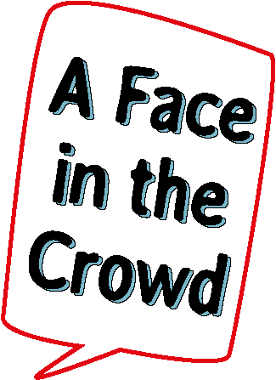
Wexford Mental Health Association are delighted to announce that our very own……….Discover Recover Theatre Project - “A Face in the Crowd”
Will be touring this November and January.
“The real human experience of mental health difficulties, are all around us, but we often don’t see it. It is rarely spoken about and the details of the impact on individuals and families are rarely shared.
This project through the sharing of sincere true life stories offers not only a rare glimpse into a hidden world, but also offers enlightenment and hope.”
This project is a partnership between the HSE Mental Health Services, the Wexford and Carlow Mental Health Associations, ESB Funds for Generations and the National Lottery.
The project originated in Wexford in 2015, with sell out performances in the Wexford Arts Centre between Dec 2015 and Jan 2016 and, in Nov 2016 a schools version toured secondary schools in Wexford County with very positive feedback.
Please see below the details of the both the public and schools performances over the coming months:
 | Thursday  16th November  2017 | Friday  17th November  2017 | Thursday  23rd November  2017 | Friday  24th November  2017 | Thursday  4th January  2018
 | Carlow  The Visual-George Bernard Shaw Theatre | Enniscorthy  Presentation Centre | Wexford  Arts Centre | Wexford  Arts Centre | Dublin  Smock Alley Theatre- First Fortnight Festival
Schools Performance(s) | 2:30pm | 11am& 2pm | 11am& 2pm | 11am& 2pm
Public Performances | 8pm | 8pm | 8pm | 8pm | 8pm
For bookings for public performances please contact the venues directly.
For further information and schools bookings, please contact: Paula Lowney 087 2754752 paula.lowney@hse.ie

