+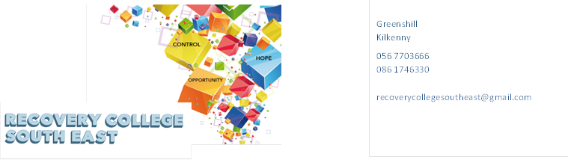
Website: www.recoverycollegesoutheast.com
Wexford Calendar of Events Autumn/Winter 2018
All our courses and workshops are co-produced and co-delivered with those who have lived experience in partnership with professional expertise, “the expert by experience working alongside the expert by profession”. Courses and workshops at the Recovery College South East are for everyone. Recovery College South East uses an educational approach to develop strengths, talents and personal resources.
VENUE | WORKSHOP NAME | DATES | TIME
August 2018
Wexford Mental Health Association, Henrietta St, Wexford | WRAP – Level 1 (2 full days)  WRAP is for everybody. It is a tool to help us to achieve and maintain wellness and gain more control over our lives and the way we feel. It is designed to help us identify what works and what doesn’t work and how we can get better at staying well. | Thursday 16th and Friday 17th August | 9.30am – 4.30 pm
Church Institute, Enniscorthy | WRAP Level (2 Full Days)  WRAP is for everybody. It is a tool to help us to achieve and maintain wellness and gain more control over our lives and the way we feel. It is designed to help us identify what works and what doesn’t work and how we can get better at staying well. | Monday 27th and Tuesday 28th August | 9.30am – 4.30pm
LINK  Enniscorthy | WRAP Café  A monthly group where you can reflect on using WRAP in everyday life to support recovery and wellbeing. Anybody who has completed WRAP Level 1 or is interested in finding out more about WRAP is welcome to attend. | Second Friday of every month | 11.30am – 1pm
Summerhill, Wexford | “Wexplorers” Sports Programme Committee  The Wexford Mental Health Services Sports Programme has been running since 2006 and is open to people who attend the Wexford Mental Health Service. The sports programme committee is a co-produced group of sports programme members and staff who meet regularly throughout the year to oversee developments in the programme i.e. organising the annual holiday, social outings etc. This group allows participants to develop organisational and leadership skills and contribute to service development. | Every Thursday in August and September | 4pm – 5pm
Carn House  Enniscorthy | Introduction to Mental Health Services  Are you new to the Mental Health Services? This introduction session will help you to learn more about the service, community resources and mental health supports. This programme helps to answer any questions you might have about your care and signpost you to appropriate supports both within the mental health services and the community. | First Wednesday of every month | 3pm – 4pm
October 2018
Wexford Mental Health Health Association, Henrietta St, Wexford | Developing Self Esteem and Confidence  This workshop will focus on understanding the importance of self-confidence and self-esteem for wellbeing; strategies for developing and building confidence and self-esteem; self-awareness; how our beliefs and values impact us; expectations we put on ourselves etc. | Monday 1st October | 9.30am – 1pm
Health Living Centre, New Ross | Developing Self Esteem and Confidence  This workshop will focus on understanding the importance of self-confidence and self-esteem for wellbeing; strategies for developing and building confidence and self-esteem; self-awareness; how our beliefs and values impact us; expectations we put on ourselves etc. | Tuesday 2nd October | 9.30am – 1pm
LINK  Enniscorthy | Introduction to Mindfulness  This workshop provides participants with an introduction to mindfulness and an overview of different tools and strategies to help apply mindfulness practice to daily life. | Friday 19th October | 9.30am – 1pm
Astro Active,  Enniscorthy | Psychosis and Me  This workshop provides an overview of the experience of living with psychosis. It also provides participants with the opportunity to learn more about different tools that support recovery. | Thursday 25th October | 2pm – 4.30pm
November 2018
Wexford Mental Health Association, Henrietta St, Wexford | Understanding the Mental Health Services  This workshop will provide a broad understanding of the structure and functions of the Mental Health and /or Addiction Services and empower our students to make recovery gains from using these services. | Monday 12th November | 9.30am – 12.30pm
Wexford Mental Health Association, Henrietta St, Wexford | Let’s Talk Depression  This workshop covers information about depression, how it is diagnosed and how it affects different people. We also look at the different tools for managing depression. This is a space to discuss your experiences and learn from others too. | Thursday 15th and Thursday 22nd November | 9.30am – 1pm
Wexford Mental Health Association, Henrietta St, Wexford | WRAP – Level 1 (2 Days)  WRAP is for everybody. It is a tool to help us to achieve and maintain wellness and gain more control over our lives and the way we feel. It is designed to help us identify what works and what doesn’t work and how we can get better at staying well. | Thursday 29th and Friday 30th November | 9.30am – 4.30pm
 | December 2018
Wexford Mental Health Association, Henrietta St, Wexford | Recovery Principles and Practice  Recovery Principles and Practice aims to bring an increased awareness of the benefits of a recovery approach in mental health services. The training is built on incorporating the unique expertise that core stakeholders, service users, family members and service providers bring to the recovery process. | Thursday 6th December | 9.30am – 1.30 pm

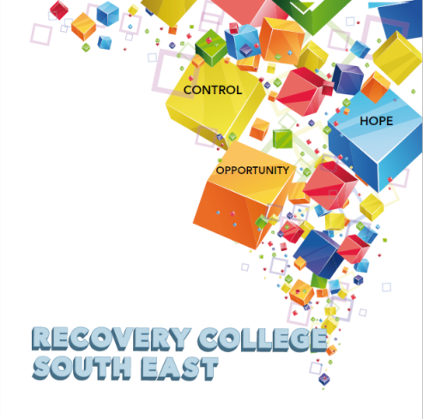

Greenshill
Kilkenny
056 7703666
086 1746330

recoverycollegesoutheast@gmail.com

Recovery College South East Enrolment Form
Course title | Commencement date

PLEASE COMPLETE USING BLOCK CAPITAL LETTERS
Surname:

First name(s)

Address:

Telephone: | Mobile | Home/Work
Contact Details in Case of Emergency: | Name | Number
Email:

All our workshops are based around discussion with some written exercises at your own discretion.

All our Workshops are free however, there is an enrolment fee of €5 per semester, per student. Our workshops are also open to everyone.

Are you happy for us to keep you informed by email, post or text about the Recovery College South East or future courses? ( Please tick this box if yes. )

Student Signature _________________________________ Date _________________________
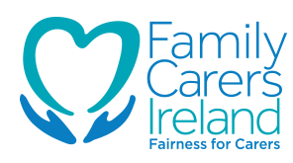
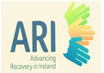
Recovery is moving on, achieving and learning, being the best and the best that I can be with confidence” Mental Health Discussion Group Clonmel 2013

