+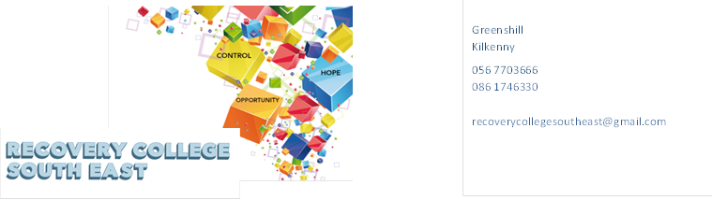
Contact No: 086 1746330
Email: recoverycollegesoutheast@gmail.com
Website: www.recoverycollegesoutheast.com
Website: www.recoverycollegesoutheast.com
Wexford Calendar of Events Spring 2019
All our workshops are focused on well-being and recovery and are co-produced and co-delivered with those who have lived experience in partnership with professional expertise, “the expert by experience working alongside the expert by profession”. Courses and workshops at the Recovery College South East are free and open to all. Recovery College South East uses an educational approach to develop strengths, talents and personal resources. Please contact us with any queries and return the enrolment form below if you wish to attend any of the workshops.
VENUE | WORKSHOP NAME | DATES | TIME
January 2019

LINK  Enniscorthy | WRAP Café “Goal Setting”  A monthly group where you can reflect on using WRAP in everyday life to support recovery and wellbeing. A different topic is covered every month. Anybody who has completed WRAP Level 1 or is interested in finding out more about WRAP is welcome to attend. | Friday 11th January | 11.30am –1.00pm
Kilcannon  Enniscorthy | WRAP Level 1 (2 full days)  WRAP is for everybody. WRAP helps you to get to know yourself. WRAP is your personal plan which you have put in place in the good times to remind you and guide you through the bad times. WRAP helps to achieve and maintain and wellness and gain more control over our lives and the way we feel. It is developed to help us identify what works and what doesn’t work and how we can get better at staying well. | Tuesday 15th January and Wednesday 16th January | 9.30am – 4.30pm
February 2019
WMHA  Wexford | Recovery for All  What is Recovery? How do we get there? A short morning workshop to discuss: different views on recovery, the factors supporting individual recovery, barriers and ways to overcome them, as well as tools and techniques to aid the recovery journey. | Monday 4th February | 9.30am – 1.00pm
LINK  Enniscorthy | WRAP Café  A monthly group where you can reflect on using WRAP in everyday life to support recovery and wellbeing. A different topic is covered every month. Anybody who has completed WRAP Level 1 or is interested in finding out more about WRAP is welcome to attend. | Friday 8th February | 11.30am –1.00pm
Library  Enniscorthy | Recovery College Introduction  This workshop provides an overview of the Recovery College South East and its aims, objectives and opportunities. It also offers an opportunity to learn more about recovery opportunities and services available in Wexford. | Thursday 14th February | 7pm
Library  Gorey | Introduction to Mindfulness  Mindfulness is a helpful tool in maintaining wellness. This workshop provides participants with an introduction to mindfulness and an overview of different tools and strategies to help apply mindfulness practice to daily life | Thursday 28th February | 10.30am –1.30pm
March 2019
Healthy Living Centre  New Ross | Let’s Talk Recovery  What is Recovery? How do we get there? A short morning workshop to discuss: different views on recovery, the factors supporting individual recovery, barriers and ways to overcome them, as well as tools and techniques to aid the recovery journey | Tuesday 5th March | 9.30am – 1pm
Library  Enniscorthy | Developing Confidence and Self-Esteem  Confidence and self-esteem are important and helpful in living well. This workshop will focus on understanding the importance of self-confidence and self-esteem for wellbeing and strategies for developing and building self-confidence and self-esteem | Wednesday 6th March | 11am – 1.30pm
WMHA  Wexford | Recovery Principles and Practice  Recovery Principles and Practice aims to bring an increased awareness of the benefits of a recovery approach in practice and services. The training is built on incorporating the unique expertise that core stakeholders, service users, family members and service providers bring to the recovery process. | Thursday 7th March | 9.30am – 1.30pm
LINK  Enniscorthy | WRAP Café  A monthly group where you can reflect on using WRAP in everyday life to support recovery and wellbeing. A different topic is covered every month. Anybody who has completed WRAP Level 1 or is interested in finding out more about WRAP is welcome to attend. | Friday 8th March | 11.30am –1.00pm
WMHA  Henrietta St  Wexford | WRAP (4 morning workshop)  WRAP is for everybody. WRAP helps you to get to know yourself. WRAP is your personal plan which you have put in place in the good times to remind you and guide you through the bad times. WRAP helps to achieve and maintain and wellness and gain more control over our lives and the way we feel. It is developed to help us identify what works and what doesn’t work and how we can get better at staying well. | Thursday 14th, Friday 15th,  Thursday 21st, Friday 22nd March | 9.30am – 1.00pm
 | April 2019
WMHA  Henrietta St  Wexford | Introduction to Mindfulness  Mindfulness is a helpful tool in maintaining wellness. This workshop provides participants with an introduction to mindfulness and an overview of different tools and strategies to help apply mindfulness practice to daily life. | Thursday 4th April | 9.30am – 1.00pm
Adult Education Centre,  Gorey | Developing Confidence and Self-Esteem  Confidence and self-esteem are important and helpful in living well. This workshop will focus on understanding the importance of self-confidence and self-esteem for wellbeing and strategies for developing and building self-confidence and self-esteem | Friday 5th April | 9.30am – 1pm
Church Institute  Enniscorthy | WRAP (2 fully days)  WRAP is for everybody. WRAP helps you to get to know yourself. WRAP is your personal plan which you have put in place in the good times to remind you and guide you through the bad times. WRAP helps to achieve and maintain and wellness and gain more control over our lives and the way we feel. It is developed to help us identify what works and what doesn’t work and how we can get better at staying well. | Thursday 11th and Friday 12th April | 9.30am – 4.30 pm
LINK  Enniscorthy | WRAP Café  A monthly group where you can reflect on using WRAP in everyday life to support recovery and wellbeing. A different topic is covered every month. Anybody who has completed WRAP Level 1 or is interested in finding out more about WRAP is welcome to attend. | Friday 12th April | 11.30am –1.00pm
 | May 2019
Healthy Living Centre  New Ross | Diagnosis and Beyond  This workshop will provide a broad understanding of diagnosis in mental health and addiction. It also explores the barriers as well as the supports in relation to diagnosis and recovery. | Tuesday 7th May | 9.30am – 1.00pm
LINK  Enniscorthy | WRAP Café  A monthly group where you can reflect on using WRAP in everyday life to support recovery and wellbeing. A different topic is covered every month. Anybody who has completed WRAP Level 1 or is interested in finding out more about WRAP is welcome to attend. | Friday 10th May | 11.30am –1.00pm

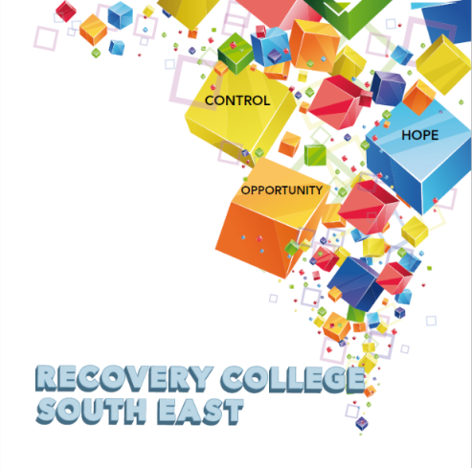

T: 086 1746330

E: recoverycollegesoutheast@gmail.com

www.recoverycollegesoutheast@gmail.com

Please return completed enrolment forms to:
Recovery College South East, Greenshill, Kilkenny.

Recovery College South East Enrolment Form
Course title | Commencement date

PLEASE COMPLETE USING BLOCK CAPITAL LETTERS
Surname:

First name(s)

Address:

Telephone: | Mobile | Home/Work
Contact Details in Case of Emergency: | Name | Number
Email:

All our workshops are based around discussion with some written exercises at your own discretion.
All our Workshops are free. Our workshops are also open to everyone.
Are you happy for us to keep you informed by email, post or text about the Recovery College South East or future courses? ( Please tick this box if yes. )

Student Signature _________________________________ Date _________________________
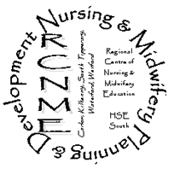
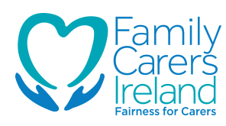
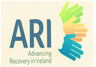
Recovery is moving on, achieving and learning, being the best and the best that I can be with confidence” Mental Health Discussion Group Clonmel 2013

