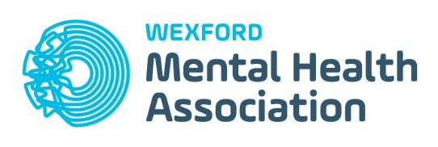

Art Photography and Craft Exhibition Application form

Wexford Mental Health Association are seeking expressions of interest from people who have an interest and passion for Art/ Craft/ Poetry/ Sculpture/Textile Art/ Photography and would like the opportunity to showcase a piece of their work during the World Class Wexford Opera Festival which is being held from the 18th October – to the 3rd November 2019. The Exhibition will be launched on Friday 18th October. Time TBC. It will be open from the 19th October and 3rd November from 11.00AM to 4.00PM each day. Applications are open to all amateurs.

Name:

Home Address

Email:
Landline:
Mobile:
How did you hear about this Exhibition?

Give a brief description and size of the piece(s) of work that you would like to exhibit?

Why would you like your Art/ photography/ sculpture/ poetry etc to be exhibited at Wexford Mental Health Association training centre?

Is there any other information you would like to add?

Name:__________________ Signature: ________________________

Please tick here ____ if you do not wish to have your piece photographed or used in any future promotion of Wexford Mental Health Association.

Please tick this box if you would like us to hold your contact details on file to notify you about future Exhibitions or events at Wexford Mental Health Association

Please tick here ________ if you do not wish for your name to be added to the piece when displayed.

Terms and Conditions Apply – See below

Signature: ____________________________________

Date: _________________

Closing date for applications: Friday 27th September 2019

Please return completed application forms to:

Wexford Mental Health Association
Henrietta Street
Wexford

Tel: 053 914 0610

Terms and Conditions:

- Note this is an Exhibition and not a competition and there are no prizes.
- Exhibition Venue: Wexford Mental Health Association, Henrietta Street, Wexford.
- Eligibility: The exhibition is open to all amateur artists who use creativity to promote positive mental health.
- Maximum two entries per person.
- Each entry should be of reasonable size, be accompanied with a title and a brief synopsis (max 50 words) about the work.
- Signing your exhibition piece or having your name attached to your submission is optional. On the submission form please tick the box if you do not wish to have your name displayed. If this box is not ticked we will assume that you have waived your right to anonymity and your name will be displayed beside your art.
- Format: Works must be original.
- All work must be clearly labelled, mountable and exhibit ready.
- A receipt for each entry will be issued.
- Buying and selling of exhibition pieces will be the responsibility of the artists.
- Liability: Every precaution will be taken from the time of receiving until the return of entries but Wexford Mental Health Association will not be liable for the loss or damage of artwork from any cause.
- Hanging and installation arrangements are at the sole discretion of Wexford Mental Health Association. Work will be presented as submitted.
- Exhibition will launch on the 18th October 2019. Exhibition will be open to the public from 11.00AM to 4.00PM on Saturdays and Sundays for the duration of the Opera Festival. Exhibition will be open on Bank Holiday Monday 28th October.
- Each piece of Art/ Craft/ Photography must be displayed for the duration of the Exhibition.

