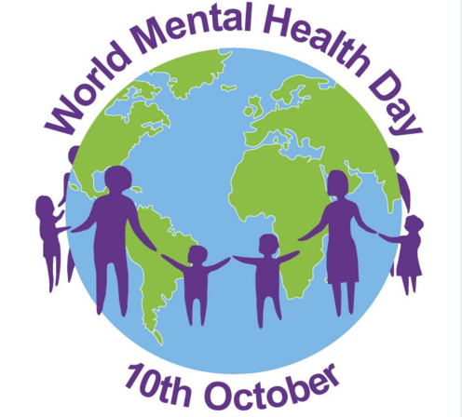

Wexford Mental Health Association Events to celebrate World Mental Health Day

Date | Event | Location
2nd October – 11.00am to 12.00pm | Mindful Discussion Group - Blend of Chair Yoga and Mindfulness with Jessica Statham from Shine Discovery | WMHA Training and Information Centre, Henrietta Street, Wexford
7th October – 11.00am to 1.00pm | Coffee with Music from Inner Harmony, Emily Redmond and Jimmy Cullen. | WMHA Training and Information Centre, Henrietta Street, Wexford
8th October 10.30am to 12.30pm | Connect Café | WMHA, Castle Street, Enniscorthy.
8th October 11.00am | Grow weekly Support Group. No intruductions needed – just come along. | WMHA Training and Information Centre, Henrietta Street, Wexford
10th October 10.30am to 12.00pm | Introduction to Mindfulness with Mark Ralph – Mindfulness Consultant | WMHA Training and Information Centre, Henrietta Street, Wexford
11th October – 11.30am to 1.00pm | WRAP Café | Link Training Centre, Enniscorthy
18th October – 3.00pm | “Creativity Counts” Exhibition launch | WMHA Training and Information Centre, Henrietta Street, Wexford

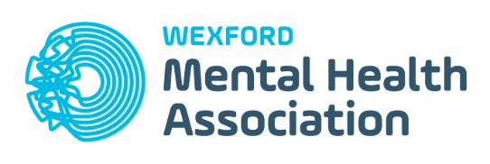
Henrietta Street,
Wexford.
Tel 053 914 0610
Email: wexfordmha@mentalhealthireland.ie

