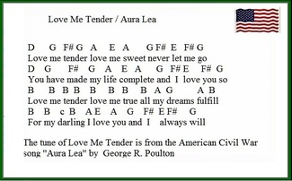

6 3 4 3 2 5 2 3 4 5 4 3
6 3 4 3 2 5 2 3 4 5 4 3
1 1 1 1 1 1 1 1 2 3 2 1
1 1 2+ 1 2 5 2 3 4 5 4 3

2+ = 2nd and 3rd finger on only for Cnatural (see tin whistle chart)

