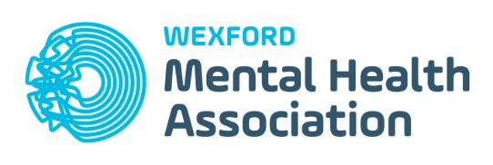

Media Consent Form

I hereby grant/do not grant permission to Wexford Mental Health Association/ Mental Health Ireland to take and use photographs and/or digital images and /or video recordings for use in printed publications or materials, electronic publications, website, social media and office displays publicising the Expressions Competition and for their Fundraising events for Wexford Mental Health Association/ Mental Health Ireland.

Participant: _________________________________

Teacher/ parent: ___________________________________

Date: _______________________________________

